**Memo**

To: Professor Pisano

From: Aidan McCall, Jonas Escobar

Team: Team 30: Smart Grid

Date: 3/4/22

Subject: 2nd Prototype Testing Plan

1. **Materials Required**

Hardware

* Smart Grid Test Facility
* DC Power Supply (3.3V, 5V)
* Oscilloscope
* Picoscope
* NI myDAQ
* Banana cables/BNC-Alligator probes

Software

* MATLAB
* MATLAB Signal Processing packages
* Proper daq driver softwares
  + NI DAQ mx Elvis/driver software
  + MATLAB Data Acquisition Toolbox
  + MATLAB Data Acquisition Toolbox Support Package for NI-DAQmx Devices
* Data collection scripts

**2.0 Setup**

2.1 Preparing the model for operation

1. Plug the power strip into the wall. Though the presence of a benchtop power supply is a current design flaw (we would like to find a solution for easier transport), we are still using it to power the control boards (MSP430s) for now.
2. Before connecting the model, the 6V output is set to 3.3V, and the +25V output is set to 5V, and both sides are grounded. With the output turned off, we wire the leads to the corresponding inputs on the outside of the model.
3. Turn on the oscilloscope and wire the leads to points 1 and 3, according to Figure 1.

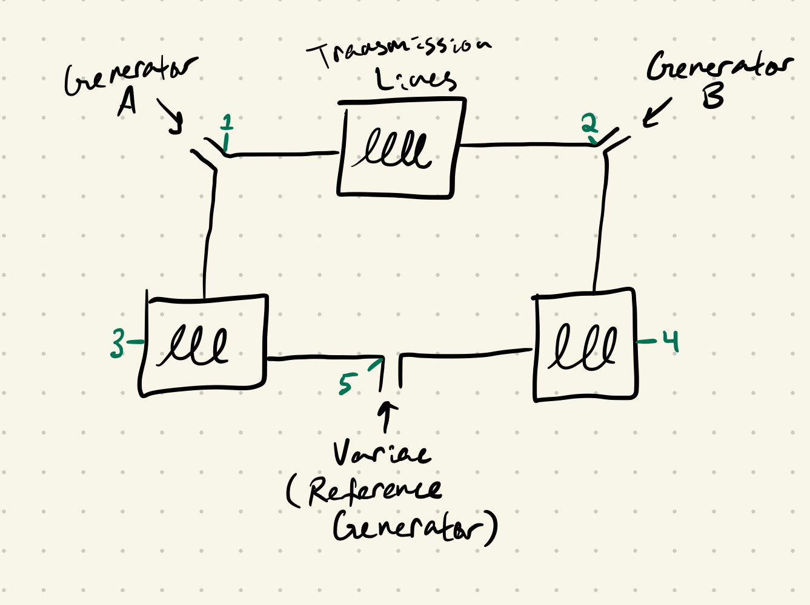

*Figure 1: Basic schematic of the grid*

1. All the hardware is set, so turn on the output of the benchtop power supply, in order to let the microcontrollers settle.
2. Then turn on the main switch on top, labeled 24V, to bring power to the rest of the model
3. The variac/reference generator is turned on after. The reference waveform should be visible on the oscilloscope (from point 3), at 60Hz and 24Vpp.

2.2 Setting up the Picoscope

1. Plug the picoscope into a computer.
2. Attach the probes to point 2 (Channel A) and point 4 (Channel B).
3. Pulling up the PicoScope 6 application should bring up a live feed with the 60 Hz, 24Vpp wave being visible on the computer.

2.3 Activating the generators and synchronizing

1. To turn on a generator, we reset the microcontroller by pressing the button labeled by an arrow for the MSP430 corresponding to that generator. When the button for A is pressed, the generator will begin its rotation and it should now be visible on the oscilloscope (from point 1). Their peak-to-peak voltage should be close to the same.
2. Next, flip the slide switch on the synchronization circuit for A to the green/on position, which will give additional feedback via the LED. The LED will flicker on and off due to the phase differences between the reference generator and the signal produced by generator A; the two signals are in phase when the LED is dim, and out of phase when it is lit up (i.e. out of phase means there will be a voltage difference across the diode causing it to be lit).
3. The toggle switch (with on/off labels) should be closed (switched to on) at a moment when the two waves are in phase.
4. Closing this will short circuit the two nodes we’re measuring on the oscilloscope, so the probe at point 3 should be moved to point 5 to compare generator A to the reference. This way we can check that the peak-to-peak voltage is remaining constant, and if it’s not then the main 24V switch should be switched off, along with the variac, to reset the model and start over. In theory, the frequency of generator A should also stabilize to 60Hz, but we’re not currently seeing this behavior.
5. These steps will be repeated for generator B, using the PicoScope to view the waveforms. After closing the toggle switch, generator B should then be compared to either generator A or the reference generator. If voltages are remaining constant, then the grid is running properly. We plan to measure A synchronization on the oscilloscope and B synchronization on the picoscope.

**3.0 Testing Procedure—Measurements through software**

3.1 Picoscope Data Analysis

1. Before synchronizing, but with both generator B and the reference generator's on, hook up the probes to point 2 and point 4.
2. After pressing the green play button, two out-of-phase 60 Hz, 24Vpp waveforms should show up on the picoscope live feed.
3. After a few seconds, save the data to a CSV file (make note of the CSV file name).
4. After synchronization, repeat the previous step, creating another CSV file under a different name.
5. Then, go to MATLAB, make sure the CSV files are in the workspace path, and input the proper file names.
6. Run the script.
   1. Two figures comparing the channel inputs for before synchronization and after synchronization should appear.
   2. Figures showing the frequency response of the 4 waveforms (Channel 1 before and after synchronization and Channel 2 before and after synchronization) should appear showing the frequency of each waveform, which should be in the vicinity of 60 Hz.
   3. The peak to peak voltage should be displayed.

3.2 Collecting data from the DAQ

Now we can add loads to the system.

1. Run MATLAB code to establish connection to the DAQ, read out available channels
   1. Make sure sensor board wiring is correct
2. Connect the resistive load to any “Load 1” output from the transmission lines, through the sensor board, and make sur
   1. Run the MATLAB script to collect data from the DAQ
   2. The voltage and current signals will be displayed, as well as the frequencies of the load circuit
3. Switch out the resistive load with inductive load, repeat
4. Switch out inductive load with Citgo sign, repeat

**4.0 Measurable Criteria**

Success for this prototype testing will be measured by the following criteria:

1. Successfully start the grid with both generators synchronized and connected to the grid
   1. Synchronization means the 2 generators are connected to the grid and no major changes in frequency and Vppp are observed. Note: synchronization does not mean all three generators will be in phase.
2. Successfully connect the picoscope to the grid, and observe the live feed, using it to synchronize generator B.
3. Successfully download a .CSV file from the picoscope and run the MATLAB script on the data collected.
   1. The MATLAB script should output frequencies of 60 Hz +/- 10 Hz, and peak to peak voltages of 24 Vpp +/- 5V.
4. Successfully connect and collect data from the DAQ, understand what the data is showing about the loads inserted to the grid.